
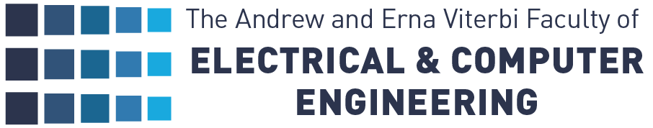

Final Report: Project A

Quantum Enhanced Electron Microscopy

Students:

Omry Maor
Ori Yehoshua

Supervisor:

Shiran Even-Haim

Semester: Spring 2025
Date: March 2026

Table of Contents
List of Figures 2
List of Equations 3
List Of Tables 4
1 Abstract 5
2 Introduction and Motivation 3
3 Background and Literature Survey 4
3.1 Quantum Metrology and Phase Estimation 4
3.2 Spin Squeezing in Electron Microscopy 4
3.3 Quantum Enhanced Multiple Phase Estimation 6
4 Chosen Method and Implementation 7
4.1 The Discretized Multipixel Framework 7
4.2 Noise Modeling via Particle Loss 7
4.3 Numerical Implementation and Optimization 8
5 Results 10
5.1 Fundamental Baselines 10
5.2 Optimization Results 10
6 Conclusions 16
6.1 Multipixel estimation dramatically improves resolution for a given dose 16
6.2 Results match theoretical optimum for high transmission 16
7 Future Work 18
7.1 Investigating the Correlation Between Transmission and Phase 18
7.2 Exploring Alternative Robust States 18
7.3 Applying Different Evaluation Metrics 18
8 References 19

List of Figures
Figure 1: High-resolution image without damaging the material 3
Figure 2: The two spin-squeezing methods we explored during our project [2] 5
Figure 3: The multiphase estimation scheme [1] 6
Figure 4: Results for $η=0.80$ 11
Figure 5: Results for $η=0.90$ 11
Figure 6: Results for $η=0.95$ 12
Figure 7: Results for $η=1.00$ 12
Figure 8: Results for a spatial-varying transmission parameter $η=(1.0, 0.5)$ 13
Figure 9: $Tr\left[I_{θ}\left(ψ_{in}\right)\right] vs. p$ and CRB for a non-optimized uniform superposition state 14
Figure 10: ${\left|\left\langle ψ_{in} | ψ^{*}\right\rangle \right|}^{2}$ for the optimal states of varying $\left(η,p\right)$ combinations 15

List of Equations
1) Initial State 7
2) The Channel 8
3) Output State 8
4) QFI Matrix 9
5) Optimization Objective 9
6) Reference State from [1] 10

List Of Tables
Table 1: QFI of optimized states vs. reference state in % for varying $η,p$ values 13

Abstract
In this project, we investigated methods for improving the resolution in electron microscopy using quantum information under a radiation dose limit. Initially, we explored spin squeezing techniques that allow overcoming the classical limit (SQL), but we shifted our research direction to multipixel phase estimation, since practically, the phase estimation of the electron in a microscope occurs across multiple pixels in parallel.
This solution is based on paper [1], which demonstrates that the simultaneous estimation of multiple phases provides an asymptotic advantage of $O\left(d\right)$ over the separate estimation of each phase. Subsequently, we ran simulations and optimized the quantum states under a noisy channel model involving particle loss in a beam splitter with a single environmental mode, as well as a beam splitter with an environmental mode for each particle independently.
The results show that multipixel phase estimation dramatically improves the resolution for a given radiation dose, and that the obtained optimal states correspond to the ideal states from paper [1] with high overlap.
In doing so, we essentially demonstrated that under a simple noise model, a significant quantum advantage can be achieved in particle phase estimation under a radiation dose constraint – an achievement of great importance in various scientific fields.

Introduction and Motivation
Efficient microscopy is a critical requirement in biology. Transmission Electron Microscopes (TEMs) can achieve atomic resolution; however, they are highly limited by beam-induced radiation damage. Consequently, imaging sensitive samples requires an extremely limited electron dose, which fundamentally degrades image precision.
The overarching goal of the research team is to improve electron microscopy using quantum technology. Specifically, the global objective is to maximize image resolution under a finite dose by optimally utilizing the available phase information extracted from every single electron. Classical phase estimation is bounded by shot-noise limits; however, by exploiting quantum entanglement between electrons, one can surpass these classical bounds and approach fundamental quantum limits, dramatically improving the signal-to-noise ratio (SNR) for a given dose.
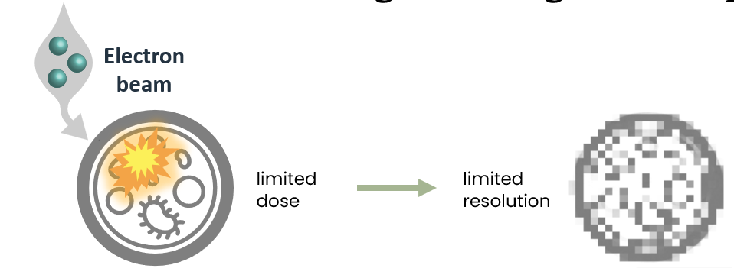
Within this larger framework, image formation must be treated as a multiparameter problem, as a single specimen imparts varying local phase shifts across a two-dimensional spatial grid of pixels. Our specific goal in this project was to find numerically optimized quantum states for multipixel phase estimation in a realistic, noisy environment. By simulating a multi-mode interferometer subjected to mixed noise channels, incorporating both independent particle loss and correlated electron loss, we aimed to identify the quantum states that yielded the lowest bound on the estimated phase’s variance. Identifying these optimal states under realistic noise lays the theoretical groundwork for future experimental efforts to implement quantum-enhanced resolution in practical electron microscopy.
Figure 1: The challenge of obtaining a high-resolution image without damaging the material

Background and Literature Survey

Quantum Metrology and Phase Estimation
To maximize the information extracted from a limited electron dose, we look to quantum metrology. Classically, the precision of phase estimation is bounded by the Standard Quantum Limit (SQL), where the phase variance scales as ${\left|Δϕ\right|}^{2}≥\frac{1}{N}$, with $N$representing the number of particles in the dose. Quantum metrology allows us to surpass this classical limit by utilizing entanglement, pushing the precision towards the theoretical Heisenberg Limit: ${\left|Δϕ\right|}^{2}≥\frac{1}{N^{2}}$.
To mathematically evaluate the potential precision of a quantum state, we utilize the Quantum Fisher Information (QFI) matrix, denoted as $I_{θ}$. The precision of multiparameter estimation is governed by the quantum Cramér-Rao Bound (CRB), which dictates that the covariance matrix of the estimated phases is lower-bounded by the inverse of the QFI matrix: $Cov\left(θ\right)≥I_{θ}^{-1}$. By maximizing the trace of the QFI matrix, we minimize the overall phase variance across all pixels, effectively minimizing the average error in the reconstructed image.

Spin Squeezing in Electron Microscopy
A prominent quantum metrological approach to surpassing the SQL is spin squeezing, which redistributes quantum uncertainty via multi-particle entanglement to reduce fluctuations in the phase variable of interest [2]. We initially explored two primary methods for generating spin-squeezed electron states in a Mach-Zehnder Interferometer (MZI): Interaction-Based Squeezing, which exploits collective Coulomb repulsion, and Measurement-Based Squeezing, which functions as a quantum non-demolition (QND) measurement.
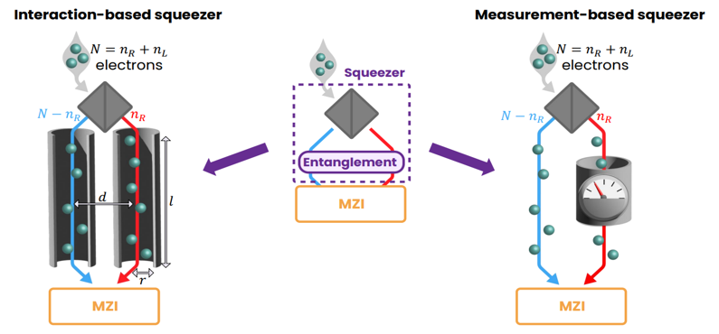
Figure 2: The two spin-squeezing methods we explored during our project [2]

While spin squeezing is highly robust against electron loss and feasible with near-future technology, practical image formation inherently occurs across multiple pixels in parallel. Therefore, rather than immediately attempting to extend single-parameter spin-squeezing methodologies to multi-pixel arrays, we shifted our research focus to identifying and optimizing initial states inherently designed for simultaneous multiparameter (multipixel) estimation.

Quantum Enhanced Multiple Phase Estimation
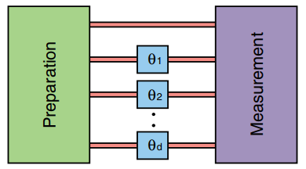
To address the multiparameter nature of imaging, we base our approach on the framework of multipixel phase estimation [1]. In this model of phase imaging, an interferometer is divided into a preparation stage, an interaction stage, and a measurement stage. $N$particles are distributed across $d+1$modes, where $d$ modes act as independent signal pixels that acquire independent phases, and one mode serves as a reference: $θ=\left(θ_{0},θ_{1},θ_{2},…,θ_{d}\right)$.
Figure 3: The multiphase estimation scheme [1]

Simultaneous estimation of multiple phases yields a fundamental quantum advantage. Estimating phases independently with quantum resources (such as states) allocates only $\frac{N}{d}$ electrons per phase, yielding a total variance scaling of ${\left|Δθ\right|}^{2}≥\frac{d^{3}}{N^{2}}$. In contrast, a simultaneous multipixel approach utilizing an optimized quantum probe state achieves a total variance scaling of ${\left|Δθ\right|}^{2}≥\frac{{\left(1+\sqrt{d}\right)}^{2}d}{4N^{2}}$. This provides an asymptotic $O\left(d\right)$ advantage over the best separate estimation strategies in the Heisenberg limit [1].

Chosen Method and Implementation

The Discretized Multipixel Framework
To investigate optimal input states for simultaneous multiparameter estimation, we modeled the electron microscope as a discretized $d+1$ mode Mach-Zehnder interferometer. In our model, we distributed $N$ electrons across target signal modes (representing the sample pixels) and one reference mode [1].
We defined our general pure input state $|ψ⟩$ as a coherent superposition of all possible configurations for distributing these $N$ particles. The total number of possible configurations, $D$, is given by the combinations of placing indistinguishable particles into distinct modes: $D=\frac{\left(N+d\right)!}{N!d!}$.
We assigned a complex probability amplitude $α_{l}$ to each basis configuration (Fock state) $\left|N_{l}\right\rangle ≜ \left|N_{l,0},…N_{l,d}\right\rangle$, so that overall, we defined the input state as written in equation 1:
1) Initial State | $${\left|ψ\right\rangle }_{in}=\sum_{l=1}^{D}{α_{l}\left|N_{l}\right\rangle }$$
Where $N_{m,k}$ represents the number of electrons passing through mode $k$ in configuration $m$. During the interaction stage, we treated the specimen as a multi-mode phase shifter. We modeled the phase accumulation by applying a unitary transformation $U_{θ}$ to the state, where each signal mode acquired an independent phase $θ_{m}$ corresponding to the local properties of the sample at that specific pixel.
Overall, the evolved state is given by: ${\left|ψ\right\rangle }_{out}=U_{θ}{\left|ψ\right\rangle }_{in}=\sum_{l=1}^{D}{α_{l}e^{iN_{l}∙θ}\left|N_{l}\right\rangle }$.

Noise Modeling via Particle Loss
Because theoretical quantum states, especially those exhibiting optimal Heisenberg-limited scaling, are highly sensitive to losses, we needed to subject our multipixel phase estimation framework to a realistic noise model.
We modeled environmental noise strictly as a particle loss channel implemented via beam-splitter interactions. We specifically chose to attribute this loss to mechanisms like high-angle scattering (e.g., Compton scattering). We defined the loss using a transmission parameter, $η$, scaling from 0 (complete loss) to 1 (perfect transmission). Although we examined the complete range of $η$ values in our simulations, we will focus heavily on high transmission parameters in this report. This is due to the properties of biological specimens in cryo-EM, which typically act as "weak phase objects". For these samples, the probability of complete electron scattering is extremely low, meaning the transmission parameter remains close to unity ($η≈1$).
To thoroughly explore the noise landscape, we evaluated two extremes of environmental loss, which we combined using a mixture parameter $p$:
- Independent Loss ($E_{seperate}$): We modeled localized scattering events where each spatial pixel (mode) lost particles to its own independent environmental mode.
- Correlated Loss ($E_{int}$): We modeled collective spatial losses where all pixels interacted with a single, shared environmental mode.
We constructed the global noise channel transformation as a weighted sum of these two extremes, as seen in equation 2:
2) The Channel | $$E\left(ρ\right)=pE_{seperate}\left(ρ\right)+\left(1-p\right)E_{int}\left(ρ\right)$$
Where $ρ$ is the density matrix of the state entering the channels.

Numerical Implementation and Optimization
To find the optimal initial states under these noisy conditions, we implemented a numerical simulation in Python utilizing the QuTiP (Quantum Toolbox in Python) library.
In our simulation workflow, we first generated the basis of the Fock space for the $D$ configurations (equation 1) and defined their corresponding density matrices. We then took that input state, passed it through the unitary phase-shift transformation $U_{θ}$, and subsequently applied our mixed environmental loss channel to compute the final output density matrix, $ρ_{out}$. Thus, the output state is defined as: (equation 3)
3) Output State | $$ρ_{out}=p∙E_{seperate}\left(U_{θ}ρ_{in}U_{θ}^{†}\right)+\left(1-p\right)∙E_{int}\left(U_{θ}ρ_{in}U_{θ}^{†}\right)$$
The QFI matrix for mixed states is given by [3]: (equation 4)
4) QFI Matrix | $$I_{θ}\left[a,b\right]=\sum_{i,j=0,λ_{i}+λ_{j}≠0}^{d}{\frac{2Re\left(\left\langle λ_{i}\left|∂_{a}ρ\right|λ_{j}\right\rangle \left\langle λ_{j}\left|∂_{b}ρ\right|λ_{i}\right\rangle \right)}{λ_{i}+λ_{j}}}$$

Where ${\left\{λ_{i}\right\}}_{i=0}^{d}$ are the state’s eigenvalues and $∂_{a}ρ$ is the differentiation of the state $ρ$ with respect to the phase $θ_{a}$.
Our primary goal was to maximize the total amount of phase information we could extract from the system. According to the Cramér-Rao Bound, minimizing the trace of the inverse-QFI matrix, $I_{θ}^{-1}$, directly minimizes the overall variance in our multiparameter phase estimation. Therefore, we defined our optimization objective as described in equation 5:
5) Optimization Objective | $$\min_{α∈C^{D}:\left|\left|α\right|\right|=1}{Tr\left[I_{θ}^{-1}\left(α, η,p,θ\right)\right]}$$

By running this optimization across varying levels of independent and correlated noise, we successfully mapped out which initial quantum states were most robust and provided the highest theoretical resolution for a given electron dose.

Results

Fundamental Baselines
We executed our simulation using $N=3$ electrons distributed across $d=2$ signal modes (yielding 3 total modes when including the reference). This setup resulted in $D=10$ possible configurations (Fock states). To quantify the quantum advantage obtained by our optimized states, we evaluated the maximized trace of the Quantum Fisher Information (QFI) matrix against three fundamental baselines:
- The Classical Limit (SQL): The lowest possible bound on the estimated phase variance achievable without quantum entanglement: ${\left|Δθ\right|}^{2}≥\frac{d^{2}}{N}=\frac{4}{3}≈1.33$. For $N=3,d=2$
- The Independent Quantum Strategy: The precision achieved by separately estimating each of the $d$phases using optimal independent states that obtain the Heisenberg Limit, scaling as ${\left|Δθ\right|}^{2}≥d∙{\left(\frac{N}{d}\right)}^{-2}= \frac{d^{3}}{N^{2}}=\frac{8}{9}≈0.89$.
- The Multipixel Quantum Limit: The theoretical optimum for simultaneous multiparameter estimation using optimal input states in a noiseless setup [1]: ${\left|Δθ\right|}^{2}≥\frac{{\left(1+\sqrt{d}\right)}^{2}d}{4N^{2}}≈0.27$. The input state that achieves this bound is found in [1] to be: (equation 6)
6) Reference State from [1] | $${\left|ψ\right\rangle }^{*}=\frac{1}{\sqrt{1+\sqrt{d}}}\left|0,0\right\rangle +\frac{1}{\sqrt{d+\sqrt{d}}}(\left|N,0\right\rangle +|0,N⟩)$$
Where in our notation, $\left|i,j\right\rangle$ such that $i+j<N$ implies that $N-i-j$ electrons pass through the reference mode.

Optimization Results
Focusing on the high-transmission regime, we plotted $Tr\left[I_{θ}\right]$ vs. $p$ for the optimal states for varying $η$ parameters, to quantify the amount of information on the unknown phases these states hold. Furthermore, we compared the optimal state with the best Cramér-Rao Bound to the 3 baselines above, as seen in figures 4-7:
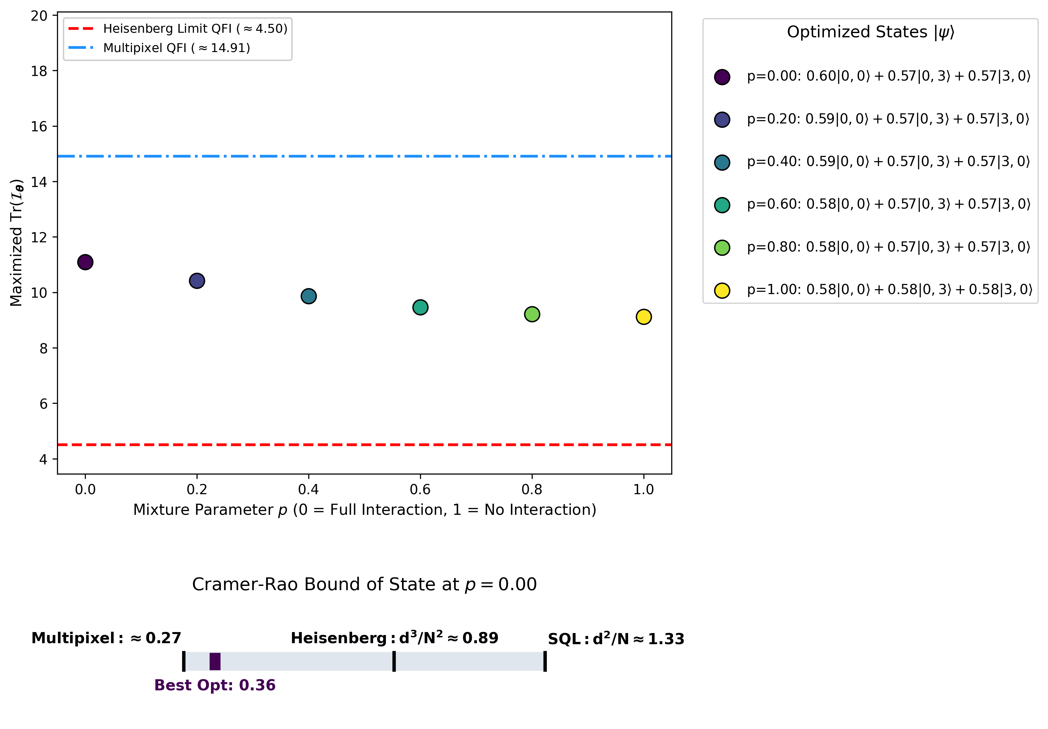
Multipixel: $≈0.32$
Figure 4: Results for $η=0.80$

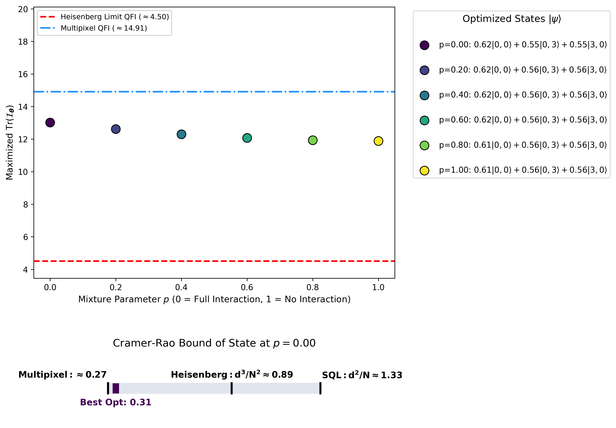
Multipixel: $≈0.32$
Figure 5: Results for $η=0.90$
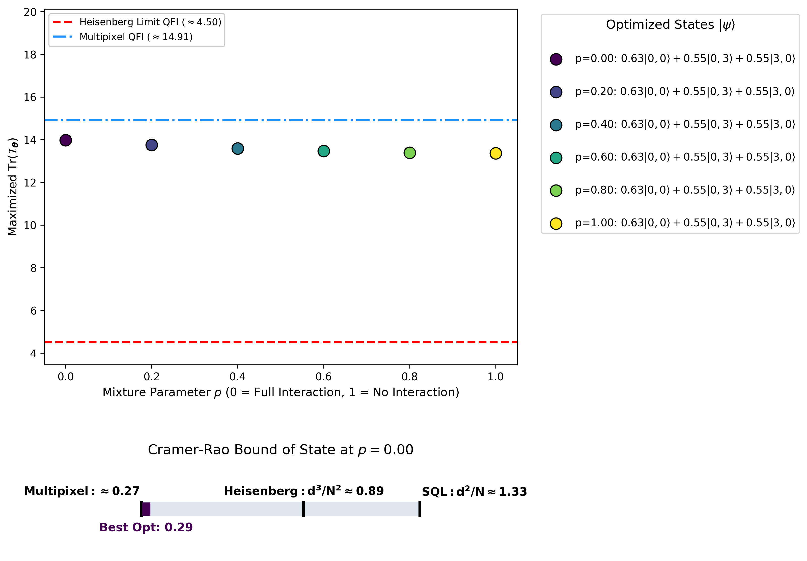
Multipixel: $≈0.32$
Figure 6: Results for $η=0.95$

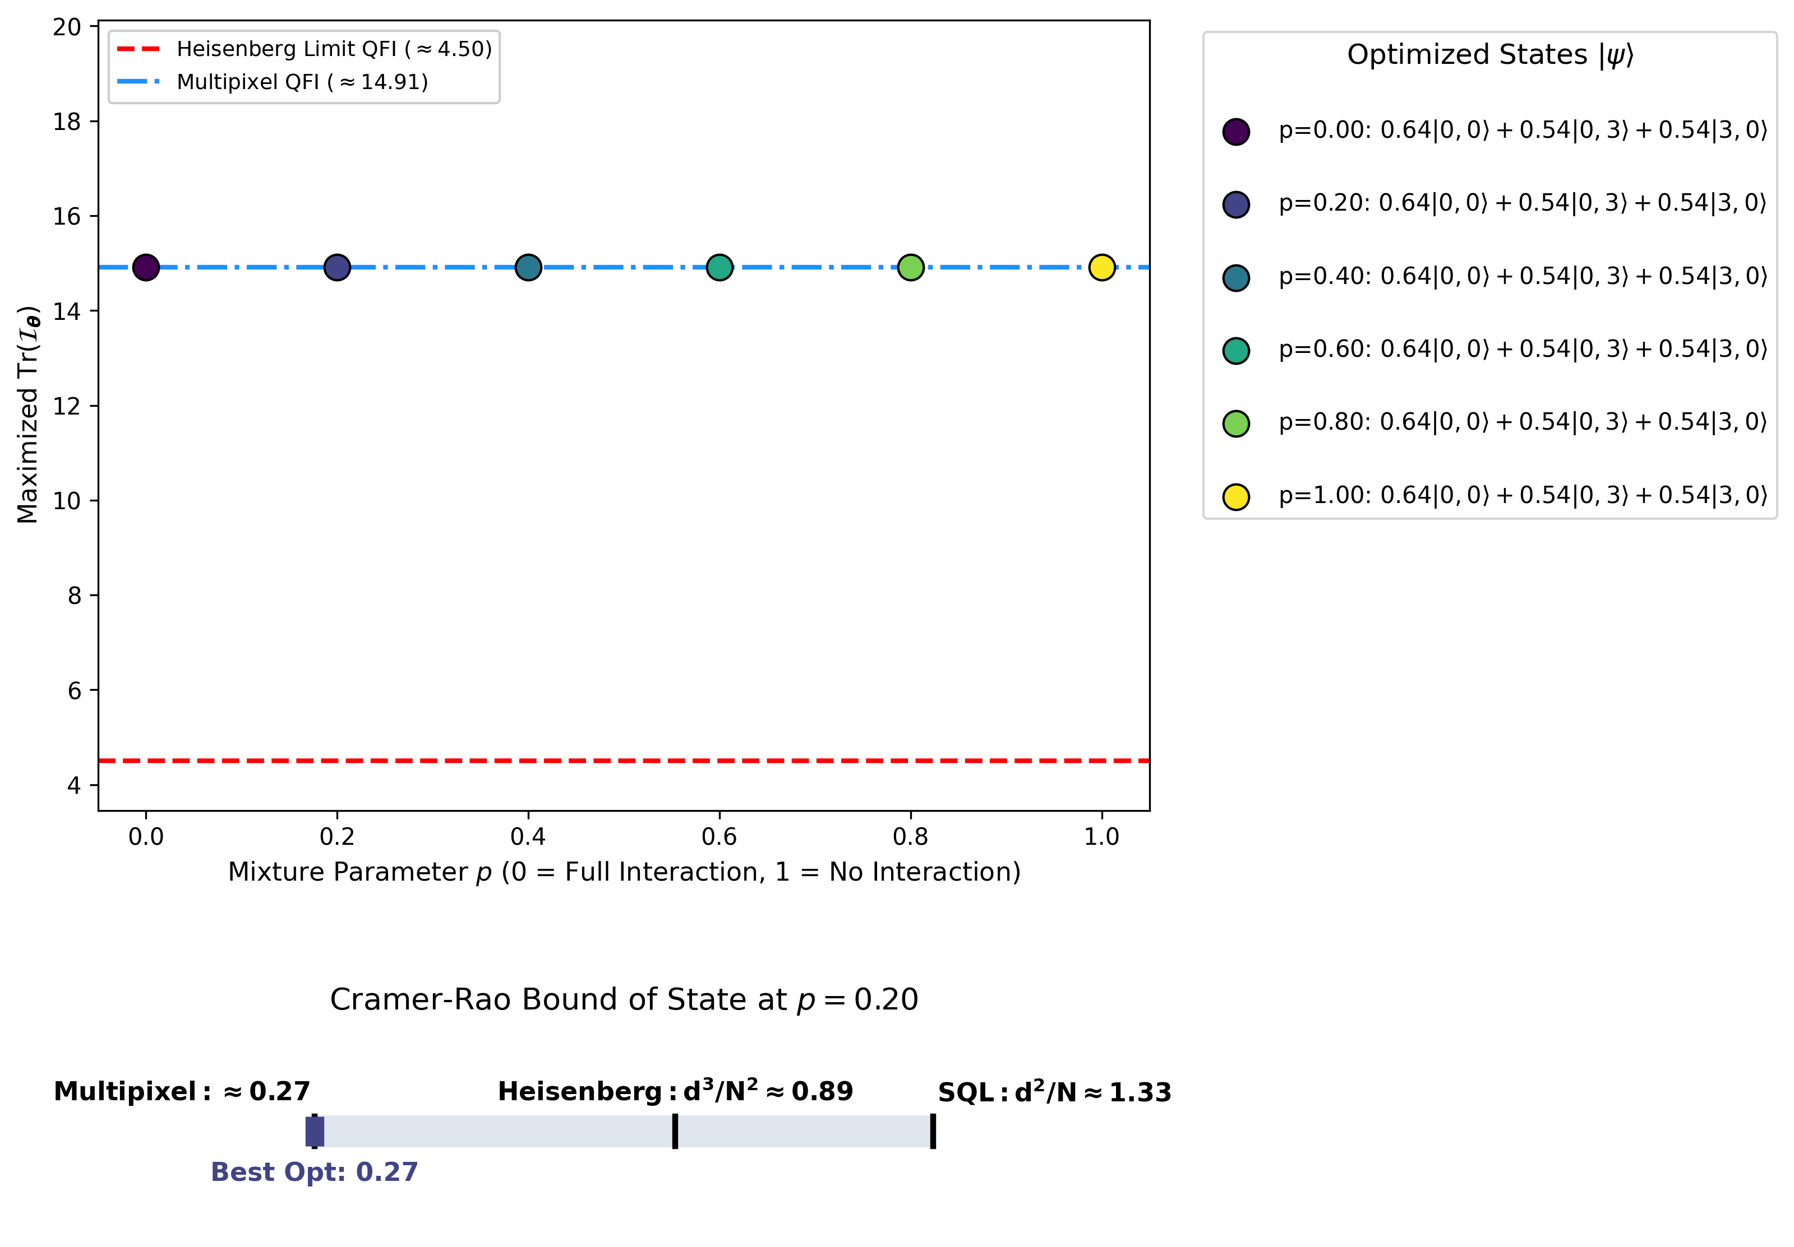
Best Opt: $0.32$
Multipixel: $≈0.32$
Figure 7: Results for $η=1.00$
As shown in the figures above, for all transmission levels, our optimized states successfully surpassed not only the classical SQL baseline across all values of $p$, but also the Heisenberg Limit for independent pixel estimations. Furthermore, we noticed that the optimal QFI results degrade monotonically as $p$ increases. We compared the results to the CRB (equation 5) of the reference state (equation 6) in percentage, in table 1:
Mixture parameter  $p$  Transmission  parameter $η$ | $$p=0$$ |  | $$p=0.5$$ |  | $$p=1$$
 | Max QFI | $\%$ of Bound | Max QFI | $\%$ of Bound | Max QFI | $\%$ of Bound
$$η=0.80$$ | 11.10 | 74.4% | 9.65 | 64.7% | 9.13 | 61.2%
$$η=0.90$$ | 13.02 | 87.3% | 12.18 | 81.6% | 11.88 | 79.7%
$$η=0.95$$ | 13.97 | 93.7% | 13.52 | 90.6% | 13.37 | 89.6%
$$η=1.00$$ | Results align with reference to $14.91$: 100% for all $p$ values
Table 1: Computation of $Tr{\left[I_{θ}( | ψ\right\rangle }_{in})]/Tr{\left[I_{θ}( | ψ\right\rangle }^{*})]* 100\%$ for varying $η,p$ values

In addition to optimizing the QFI for a constant $η$ over all modes, we examined the optimal states for a setup with varying $η$ over the different modes. Meaning, in this setup, $η$ is a vector where $η_{i}$ represents the transmission parameter $η$ of mode $i$ ($i=0,1,…,d$). The results are shown in figure 8:
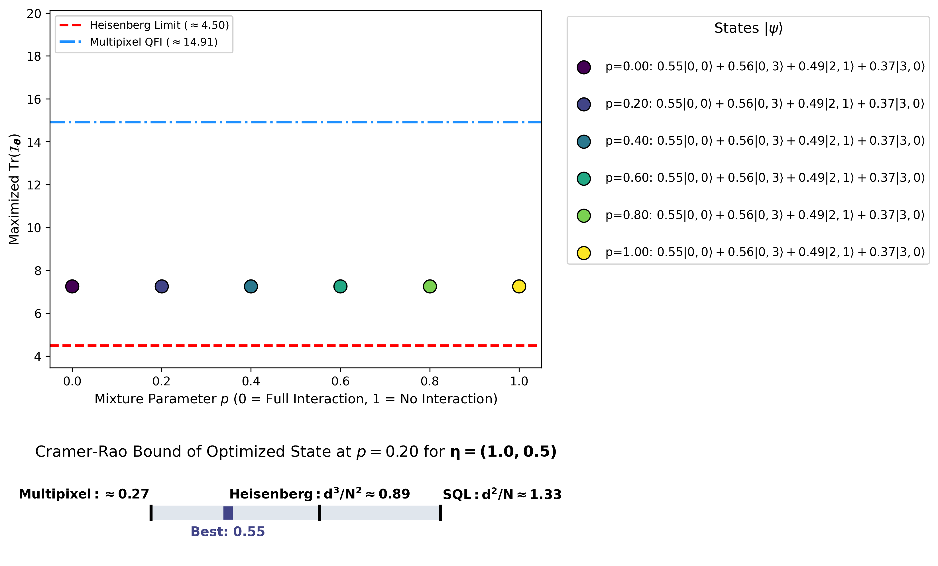
Multipixel: $≈0.32$
Figure 8: Results for a spatial-varying transmission parameter $η=(1.0, 0.5)$
For the setup described in figure 8, the optimal input state for all $p$ values is the same state: $\left|ψ\right\rangle =0.55\left|0,0\right\rangle +0.56\left|0,3\right\rangle +0.49\left|2,1\right\rangle +0.37\left|3,0\right\rangle$. Interestingly, since the spatially varying $η$ brakes the symmetry between the $d$ modes, the optimal state is not symmetrical.
Furthermore, we examined the performance of an arbitrary (not optimized) input state. for this task, we chose the uniformly distributed superposition state:
$$\left|ψ_{in}\right\rangle =\frac{1}{\sqrt{D}}(\left|0,0\right\rangle +\left|0,1\right\rangle +\left|0,2\right\rangle +\left|0,3\right\rangle +\left|1,0\right\rangle +\left|1,1\right\rangle +\left|1,2\right\rangle +\left|2,0\right\rangle +\left|2,1\right\rangle +|3,0⟩)$$
We computed its corresponding $Tr\left[I_{θ}\left(ψ_{in}\right)\right]$ and CRB for $η=0.9$, as seen in figure 9:
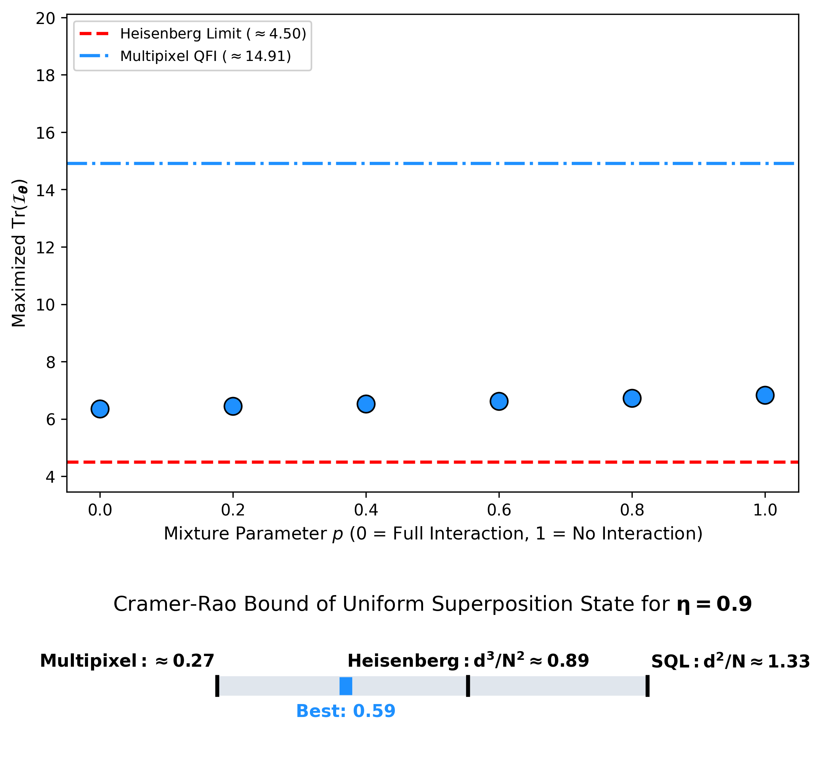
Multipixel: $≈0.32$
Figure 9: $Tr\left[I_{θ}\left(ψ_{in}\right)\right] vs. p$ and CRB for a non-optimized uniform superposition state

As demonstrated in figure 9, the multiparameter estimation results in an improvement over the Heisenberg Limit even for a general, non-optimized input state in a noisy environment.
Finally, we examined the optimal states’ fidelity across various $p,η$ combinations with the reference state from equation 6, as seen in figure 10:
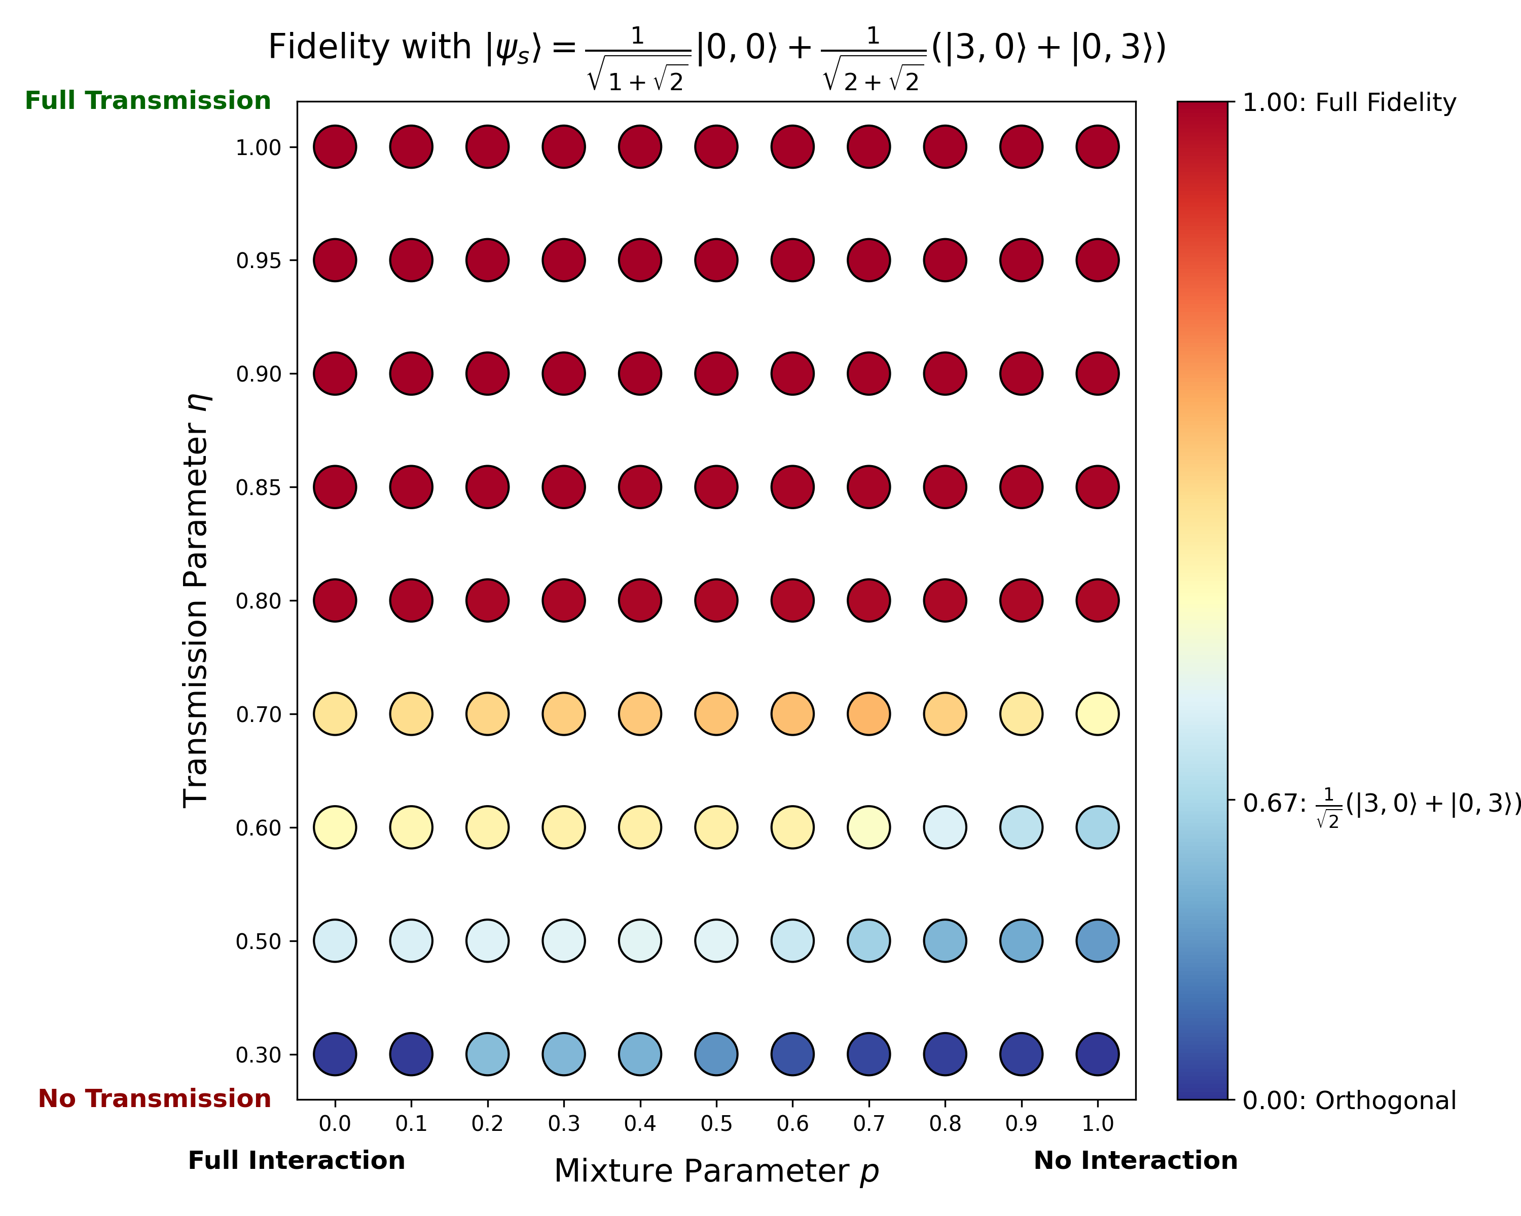
Figure 10: ${\left|\left\langle ψ_{in} | ψ^{*}\right\rangle \right|}^{2}$ for the optimal states of varying $\left(η,p\right)$ combinations
As expected, the optimized states have increasingly higher fidelity with the reference state from equation 6 for increasing $η$ values, whereas for low transmission regimes the optimal states differ significantly from the reference state.

Conclusions

Multipixel estimation dramatically improves resolution for a given dose
Throughout this project, our primary constraint was the severe radiation dose limit imposed by sensitive biological samples in transmission electron microscopy. To overcome this, our specific objective was to numerically find and evaluate optimal quantum input states that maximize extracted phase information under realistic, noisy microscope conditions.
By evaluating the performance of these numerically optimized states across our discretised model, we successfully demonstrated that simultaneous multipixel estimation fundamentally outperforms classical strategies. Specifically, adapting our states to the loss channel provided a robust variance advantage over both the classical Standard Quantum Limit (SQL) and separate independent estimation strategies. Ultimately, we confirmed that by actively optimizing correlated quantum states for a lossy environment, we can extract significantly more phase information from the exact same number of electrons, dramatically improving the allowable image resolution before beam-induced damage occurs.

For $η≥0.8, {\left|ψ\right\rangle }_{in}≈0.64\left|0,0\right\rangle +0.54(\left|3,0\right\rangle +|0,3⟩)$ is optimal
Because typical biological specimens in cryo-EM act as "weak phase objects" that impart phase shifts with relatively low electron scattering, we focused our numerical optimization heavily on the high-transmission regime. When running our simulations for transmission parameters of $η≥0.8$, we found that our optimized initial states under realistic noise exhibited an extremely high fidelity with the theoretical, noiseless optimum state (equation 6). This specific superposition structure concentrates the probability amplitude into configurations where either all particles remain in the reference mode, or all particles bunch together into a single signal mode. The fact that this specific theoretical state remained optimal even under a 20% chance of particle loss in our simulated channels validated our model, demonstrating that the ideal theoretical formulations are highly practical and robust for standard biological imaging environments.

Future Work
While our numerical model successfully demonstrated a quantum advantage under mixed particle loss channels, we identified several avenues for expanding this framework toward physical implementation. Based on our simulation results and the subsequent analysis during our project reviews, we identified the following directions for future research:

Investigating the Correlation Between Transmission and Phase
It is known that there is a correlation between an object’s transmission properties and the phase accrued by it. Throughout our work, we noticed that perhaps investigating this correlation could help finding more fitting and steady optimal input states that are tailored to the specific specimen inspected.

Exploring Alternative Robust States
Our optimization algorithm actively searched for the absolute optimal states that maximized the Quantum Fisher Information within the loss channels. However, we proposed that future research should also explore other, more general initial states. These suboptimal states might be mathematically or physically simpler to prepare in an actual microscope, while still possessing an advantage over single-parameter estimation methods.

Applying Different Evaluation Metrics
To evaluate how the loss channel degraded our optimized states, we primarily calculated their fidelity to the theoretical noiseless optimum. We concluded that future studies should compare the optimized states using alternative distance measures and performance metrics beyond pure fidelity. Analyzing the states through different mathematical lenses could yield deeper insights into their structural robustness under severe noise.

References

[1] | P. C. Humphreys, M. Barbieri, A. Datta and I. A. Walmsley, "Quantum Enhanced Multiple Phase Estimation," Physical Review Letters, vol. 111, no. 7, p. 070403, 2013.
[2] | S. Even-Haim, E. Nussinson, R. Ben-Maimon, A. Gorlach, R. Ruimy, E. Shahmoon, O. Schwartz and I. Kaminer, "Spin Squeezing in Electron Microscopy," Preprint, pp. 1-21, 2025.
[3] | J. Liu, H. Yuan, X. Lu and X. Wang, "Quantum Fisher information matrix and multiparameter estimation," J. Phys. A: Math. Theor., vol. 53, no. 2, p. 023001, 2020.

